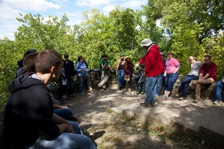
OHIO STATE SIGMA XI FIELD TRIPS 2014
TECHCOLUMBUS: HOW TO START YOUR OWN STEM-BASED COMPANY
The Ohio State Chapter of Sigma Xi sponsored a visit by 25 Ohio State students and faculty to the TechColumbus Tech Center (1275 Kinnear Rd., Columbus) on March 3, 2014. John F. Lewis Jr., BioOhio President & CEO, lead us through the stages of starting a successful company (concept, seed, startup, early, breakeven and growth) and the financial support and guidance that Tech Columbus can provide along the way. Wayne Embree, TechColumbus Executive Vice President for Investment & Venture Development, provided a reality check by identifying common problems at each step and how to avoid or overcome them. John Lewis shared a few of the success stories from companies that started in the Tech Center Incubator. Everyone left with a better idea of how they will start their company.
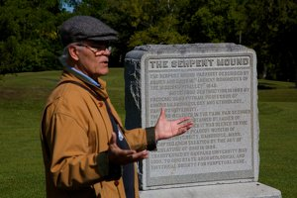
SERPENT MOUND AND ORDOVICIAN (REALLY, REALLY OLD) FOSSILS, WITH THE EXPERTS
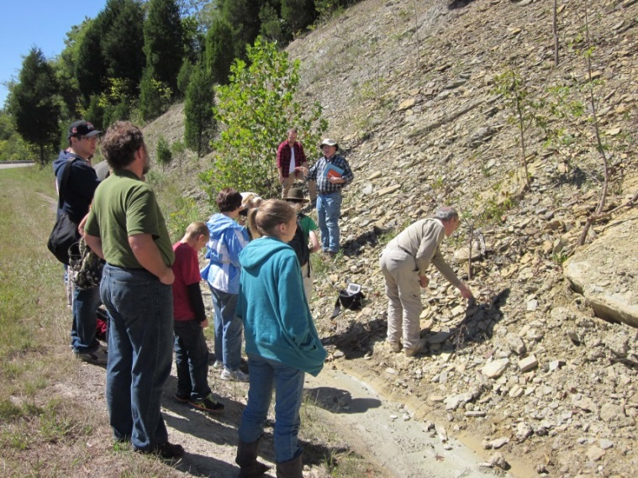
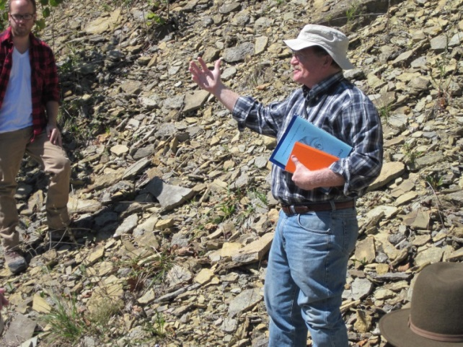
On September 14, 2014, twenty curious/lucky people joined a Sigma Xi-organized and guided field trip to Serpent Mound in southeastern Ohio’s Adams County. Our guide, Dr. Bill Dancey, Emeritus Associate Professor of Anthropology at OSU and a former president of the Ohio State Sigma Xi Chapter, has been studying Midwestern paleocultures for over 50 years. He gave us several past, and the best current ideas of who built this four foot high, 1400 foot long, undulating, linear figure that resembles a snake with a coiled tail and an open mouth swallowing an egg. Radiocarbon dating indicates that Serpent Mound was constructed around 360 BC, in the Early Woodland period by people of the Adena tradition (500-0 BC), but they did not use the mound for burial. Instead, this unique effigy is located on the edge of a four mile diameter cryptoexplosion structure that is claimed to be the reason for its placement. Alignments correspond to a variety of lunar and solar events and constellations. The effigy’s uniqueness excites the imagination and has led to its nomination for World Heritage status as one of the planet’s most significant archaeological sites.
Adams County is also famous for its Ordovician strata and the fossils they contain. Our guide, Dr. Bill Ausich, Professor and former Chair of Geology at OSU and also a former president of the Ohio State Sigma Xi Chapter, is an expert in Ordovician fossils. He explained that these ‘Cincinnatian’ strata are the oldest exposed rocks in Ohio (~450 million years old), laid down when Ohio was located south of the equator. We visited a road cut with plenty of fossils and collected both rocks and fossils from the Ordovician Period. The Great Ordovician Biodiversification ended with the late Ordovician extinctions, the second most devastating biosphere collapse experienced on Earth. More picts: http://sigmaxi.org.ohio-state.edu/.

