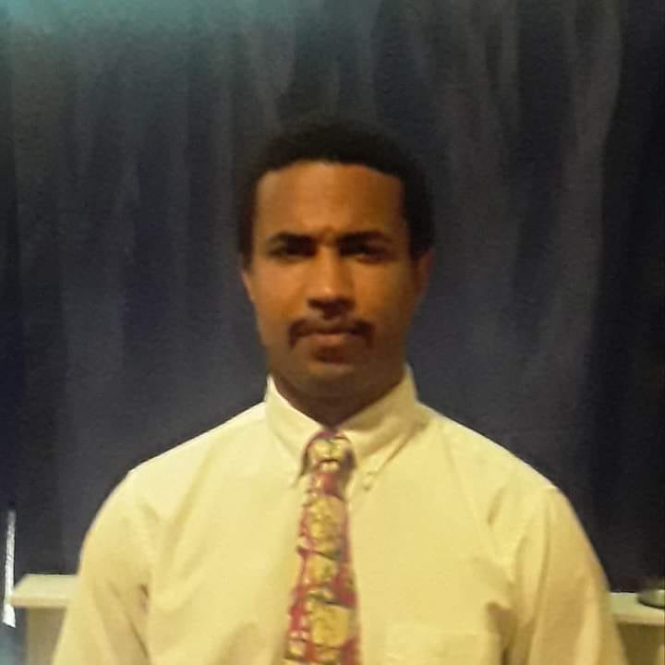

Samuel K. Williams, MD, CPG
Board Certified Physician
1402 S. Carolina Avenue
Albany, GA zip 31705
(2290485-8273
Sw56625@gmail.com

August 8, 2023
_____________________________________________________________________________________________

Current Position(s)
Clinical Instructor/Volunteer Faculty 2015-present
Philadelphia College of Osteopathic Medicine (PCOM)/Department of Internal Medicine
Suwanee, Georgia

Independent Contractor/BAA Televisitmd 2021-present
Tele-health provider in GA, LA(COVID-19), and FL

Education
Medical Entomology Certificate Program, Udemy, Albany, GA 2023

Online MBA, Eastern New Mexico University (ENMU), Portales, NM 2022-present

Online MBA, Quantic School of Business and Technology, Washington, DC 2021-2022

Johns Hopkins University (JHU) Summer Institute in Biostatistics and Epidemiology 2012

Geriatric Medicine and Gerontology Fellowship, JHU, Nashville, TN 2011-2013

Online Healthcare MBA, Florida Institute of Technology (FIT), Melbourne, FL 2011-2011

Graduate Certificate in Teaching and Learning, Walden University, Minneapolis, MN 2011
Internal Medicine Residency, Boston Medical Center, Boston, MA 2008-2011
M.D., Meharry Medical College School of Medicine, Nashville, TN 2003-2008

B.S. in Chemistry/ACS Certified (cum laude), Morehouse College, Atlanta, GA 1999-2003

HCOP (valedictorian), Savannah State University, Savannah, GA 1999

Academic Appointments
Clinical Instructor/Volunteer Faculty 2015-present
Philadelphia College of Osteopathic Medicine (PCOM)
Suwanee, GA

Certification and Licensure
Association of Drugless Practitioners(AADP), Board Certified
American Natural Wellness Practitioners Board(AANWP), Board Certified
Credentialed Professional Gerontologist (CPG), National Association of Professional Gerontologists (N.A.P.G.) (active)
American Board of Physician Specialties (ABPS) Board Eligible in Internal Medicine

Professional Development
Pretest Internal Medicine Board Review Book 2023-present
45th Annual Intensive Review of Internal Medicine (HMS)
Harrison’s Principles of Internal Medicine Self-Assessment and Board Review 2022-present
Current Medical Diagnosis and Treatment 2022 by Papadakis, Mcphee, and Rabow 2022-present
An African American Philosophy of Medicine by Dorrance 2022-present
Healing Secrets of the Native Americans by Shimer 2022
The Country Doctor by Kafka 2022
HMS Trending Topics in Internal Medicine 2.25 AMA PRA Category 1 Credits 2021
Medscape Continuing Medical Education 40.0CME 2021-present
Medscape Business Academy 2017-present
Harvard Internal Medicine Review 2017
Cardiovascular Disease Research/Boston University—Zannis Lab 2009
MIRT/Ethnobotany/Egerton University/Kenya—Cheplogoi Lab 2005
Computational Chemistry Research Laboratory/Fisk University 2004
Georgia Power Environmental Research Training—Blumer Lab 2002-2003
NASA Space Medicine and Life Sciences Research Training—Klement Lab 2002
REU Experience for Undergraduates in Integrative Evolutionary Biology—Vogt Lab 2001

Synergestic Activities
MBA in a Box by Joel Kurtzman 2022
Meharry Medical College National Alumni Association 2022-present
National Association of Medical Minority Educators, Inc. (NAMME) 2022-present
National Medical Association (NMA) 2022-present
National Black MBA Association (NBMBAA) 2022-present
The Association of Black Sociologists (ABS) 2021
American College of Physicians (ACP) 2021-2022
South Atlantic Medical Association 2020-2021
Reviewer, Journal of Healthcare for the Poor and Underserved (JHCPU) 2019
Reviewer, The Permanente Journal 2019
Member, American College of Physician’s (ACP) Insider Research Panel 2018
Morehouse College National Alumni Association, Life Member 2018-present
Founding Contributor to the USMLE Step 1 Question Bank/Examcircle.com 2017
Pro Member, International Academy of Precision Medicine (IAPM) 2016-2017
Full Member, European Medical Association (EMA) 2016-2017
100 Black Men of America, Baltimore Chapter 2014
Admitted to Georgetown’s Nephrology Fellowship 2014
Admitted to Tulane’s Nephrology Fellowship 2014
Sigma Xi, At Large 2013-present
Sigma Phi Omega (SPO), Delta Lambda Chapter 2013-present

Educational Administration
National Health Service Corps Mentoring Program 2016-2017
Mentees included Student Doctors Allison Doyle, Georgetown University SOM, Joseph Guernsey, University of Florida—College of Medicine, and Ashruta Patel, Philadelphia College of Osteopathic Medicine—Suwanee Campus, all 3 mentees are now in residency, and co-authors in "The Grandmother Principle: The Sociological Imagination Applied to Geriatric Medicine and Gerontology," in J Best Pract Health Prof Divers.

Summer Medical Education Program (SMEP) Fellow 2004
I taught general chemistry to a group of pre-medical students collaboratively with a colleague from
Meharry Medical College.

Honors and Awards
Marqui’s Who’s Who 2022
Findatopdoc.com 2020-present
Service Project Award/Sigma Phi Omega (SPO) 2022
Rural Leader Magazine’s Top Forty Under 40 2019
Patient Advocate Award, Boston Medical Center 2011
Honors in Growth, Development, and Aging Module, Meharry Medical College 2006
Robert S. Anderson Memorial Scholarship 2007
Thomas J. Blocker, Jr. Memorial Scholarship 2003
Boehringer-Ingelheim Scholarship 2000
Morehouse College Academic Scholarship 1999
Zeta Phi Beta Scholarship 1999
HOPE Scholarship 1999
Who’s Who 1999
Revlon Crème of Nature Scholarship 1999
Papa John’s Scholarship 1999

Publications
Williams, S. “Helping Brothers to Reach Their Goals: ‘Able to Focus on Studying.” Morehouse Magazine, Summer 2007, https://issuu.com/morehousemagazine/docs/summer2007.

Williams, S.K. “A Second Look at Geriatrics,” Meharry- Vanderbilt Student Alliance
Newsletter. Winter 2006/2007, Volume 4, Issue 2, Page 7, 2005.

Williams, S.K., Chao, S. “Prolonged Hypoglycemia in a Diabetic Patient
with Multifactorial Anorexia.” In: 2011 Annual Scientific Meeting of American
Geriatrics Society. May 11-14th; National Harbor, MD.Journal of the American Geriatrics Society,
Special Issue 2011 Annual Scientific Meeting Abstract Book: The American Geriatrics Society,
A5, 2011.

Williams, S.K., Block, L., Morgan, M., Cayea, D. “Rationale for the Development of an
Interdisciplinary Transitions in Care Curriculum for Medical Students,” Johns Hopkins University
IEE/SOM Education Conference poster presentation, 2012.

Williams, S., Ahmed, M., Bellantoni, M., Greenough, W.B., Finucane, T., Weiss, C.
“Transfer Risks from Chronic to Skilled Ventilator Units,” 2013 Scientific Meeting of
the Gerontological Society of America oral presentation, 2013.

Williams, S., Kirk, A., Fox, A.R., McNabney, M. “What do we know about the role of Federally
Qualified Health Centers (FQHC) in the care of poor older adults?” In: 2013 Annual Scientific
Meeting of American Geriatrics Society. May 2-5th; Grapevine, TX. Journal of the American
Geriatrics Society, Special Issue 2013 Annual Scientific Meeting Abstract Book: The American
Geriatrics Society, A96.

Williams, S. “Smart exercise a healthy lifestyle course,” Albany Herald, 09/21/2015

Williams, S. “Geriatric house calls help patients, physicians,” Baltimore Sun, 12/27/2015

Williams, S. “Routine Health Screening: We Can Do Better,” Rural Leader Magazine,
04/2016, http://ruralleadermagazine.com/.

Williams, S., Braxton, J, Gosdin, M, Nobis, N, Williams, D, “Evidence-based Care of the Elderly:
Uses of the “Grandmother Principle,” Journal of Healthcare for the Poor and Underserved,
volume 28.1, February 2017.

Williams, S. "Can We Merge Geriatrics and Entomology into a Single Field?" News of the Lepidopteran Society, Volume 60, Number 3, page 146, Fall 2018.

Williams, S., Patel, A, and Doyle, A. “The Relationship Between Age and Treatment of Adults,” The Student Doctor Network, www.studentdoctor.net, 05/31/2021.

User, S., 2022. Samuel K. Williams, III, MD, CPG. [online] Leaflet-ejournal.org. Available at: <http: www.leaflet-ejournal.org/archives-index/item/Samuel-k-williams-iii-md-cpg> [Accessed 15 July 2022].

Williams, S.K. (n.d.). “The Grandmother Principle.” Urban Dictionary. Retrieved July 15, 2022, from https://www.urbandictionary.com/define.php?term=The+Grandmother+Principle.

Williams Samuel, M., 2022. Improving the Process of Healthcare Delivery - SDN. [online] Student Doctor Network. Available at: <https://www.studentdoctor.net/2022/04/28/improving-the-process-of-healthcare-delivery/> [Accessed 15 July 2022].

Published Abstracts and Presentations
Williams, S. "The Grandmother Principle: The Sociological Imagination Applied to Geriatric Medicine and Gerontology," J Best Pract Health Prof Divers (Fall, 2019), 11(2), 161.

