Guide for Judges
Contents
Overview 2
Student Showcase Dates and Deadlines 2
Presentation Site Overview 3
Elements of a Showcase Presentation 4
Discussion Widget……………………………………………………………………………………………………………………………………5
Evaluation Process 7
Contact Information – How to volunteer 8

Overview
Scientists and engineers must communicate their research to a broad audience, people very important to their careers including funders, legislators and administrators as well as colleagues in other fields. Today, young researchers have an unprecedented array of communication tools at their disposal, and The Sigma Xi Student Research Showcase offers an opportunity to develop those vital communication skills.
This online competition connects student presenters and judges from around the world with presentations that include a written abstract, brief video and technical slide presentation. Awards will be presented for outstanding presentations.
Thank you for your interest in evaluating student presentations and providing feedback that will help prepare the next generation of research scientists and engineers.

Student Showcase Dates and Deadlines
January 2017 | Call for judges and presentations
 | Volunteer for judging: Complete the form at https://www.sigmaxi.org/meetings-events/volunteer and click on 2017 Student Showcase, and indicate the fields in which you can serve as a judge
March 31, 2017 | Deadline to volunteer as a Student Showcase judge
March 31, 2017 | Final publication of student presentations to Student Research Showcase homepage
April 3, 2017 | Student Research Showcase begins. Judges begin to review student presentations
 | Dialogue between student-presenters and judges via discussion widget on the student’s presentation site
April 10, 2017 | Judging concludes at 11:59 PM Pacific Time
April 14, 2017 | Student Award Winners Announced
April 28, 2017 | Feedback from judges sent to all presenting students

Presentation Site Overview
1 - Short Title | 2 – Presenter Information | 3 – Personal Video
4 – Discussion Widget | 5 – Abstract | 6 – Slide Presentation
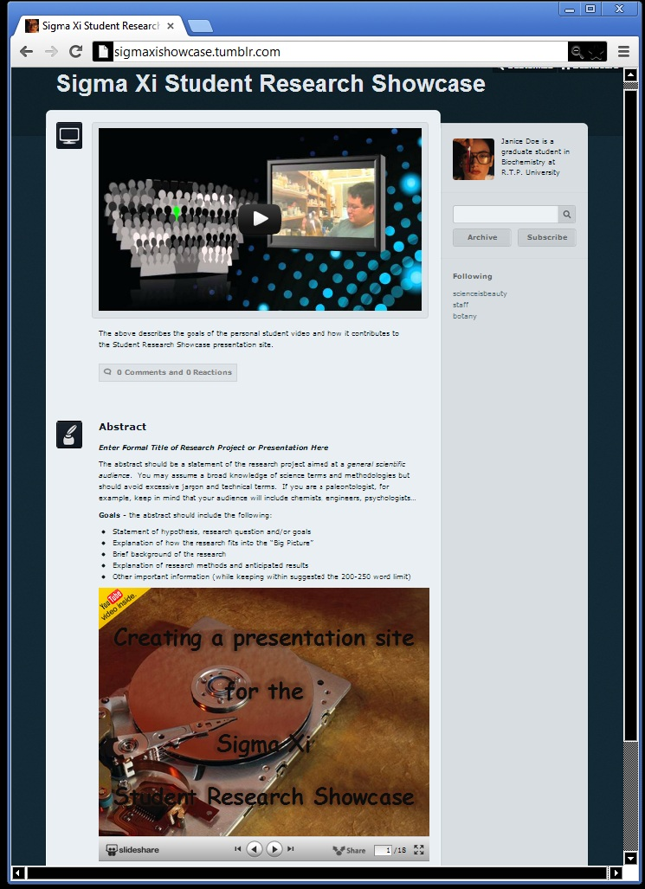
6
5
4
3
2
1

Elements of a Showcase Presentation

1. Short Title
A short title of the research project should appear near the top of the presentation page. This is not necessarily the formal title of the research project, which should appear in the abstract section (see below).
The short title should give a general idea about the topic and help confirm that the visitor is on the correct site. A formal title such as: “Fluctuating Asymmetry as an Indicator of Habitat Quality and Foraging Ability in the Tiger Salamander, Ambystoma tigrinum” could be shortened to simply: “Tiger Salamander: Foraging and Habitat.”
The short title will appear on the Sigma Xi Student Showcase home page and will be used to identify student presentations to the judges.

2. Presenter Information
Presenters should be identified by name, current education status (examples: high school senior, graduate student, freshman) and institution name. Other information (field of study for example) may be included but is not required.

3. Personal Video
- Intended Audience: judges as well as general visitors to the presentation site.
- Length: 2-3 minutes.
- Goals: serve as a means for presenters to introduce themselves and their project to judges and guests visiting the presentation site.
- The video is also an opportunity to share enthusiasm for the research project.
- The video should Include a statement of how the research fits into the big picture; described in a way that non-scientists would find compelling.

4. Discussion Widget
- Intended Audience: judges with a technical background that matches the student’s research project. Some casual visitors may also comment.
- Goal: to afford students and judges an opportunity to dialogue about the student’s research similar to how they might at a face to face event.
- Discussion behavior: Discussion widgets typically allow presenters to moderate the discussion and flag/remove any inappropriate comments. As these forums are public, Sigma Xi cannot be responsible for the content of posts. Please do alert Sigma Xi if any student or judge does post inappropriate comments. This is not acceptable and we will follow up as necessary.
  - Some of the student participants are minors. Sigma Xi therefore requests that judges to not communicate with presenting students outside of the public discussion widgets connected with the student’s presentation site.
How to Engage in Discussion with students
Most presentation sites will have DISQUS installed to allow you to interact with the student. Locate the link on the site that most likely appears as
You will then be led to a comment box that most likely appears as follows

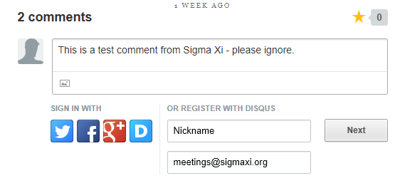
Add your comment, create a nickname and enter any email address (judge@sigmaxi.org is fine for this purpose). You will not have to formally register with DISQUS in order to submit your comment.

No Login Required
If the discussion widget insists that you log in before posting, please contact meetings@sigmaxi.org so we can instruct the student on correcting their privacy settings.

5. Abstract
- Intended Audience: visitors with a general science background but who do not have specific technical knowledge of the scientific principles behind the student’s research.
- Suggested length: 200 words maximum.
Abstracts should contain the following information
- Formal title of the research project (in bold font)
- Statement of hypothesis, research question or research goals
- Explanation of how the research fits into the “Big Picture”
- General description of research methods and anticipated results
- Findings or conclusions

6. Slide Presentation
- Intended Audience: judges with a technical background that matches the student’s research project.
- Limit: 25 content slides + 1 title slide + 1 acknowledgement slide (27 slides total).
Slide Presentation should contain the following:
- Formal title of the research project on slide 1 (may also include presenter information)
- Statement of hypothesis, research question or research goals
- Technical description of research methods and how they serve to test the hypothesis or answer the research question
- Data and results
- Findings or conclusions

**Note on Level of Technical Detail

Keep in mind that elements of the presentation serve different goals and have different levels of technical detail. Consider the following when evaluating the student’s presentation sites:
More General More Technical

Personal Video | Abstract | Slide Presentation

Evaluation Process
- Judges will be assigned a selection of student presentations that matches the judge’s general field of research.
- Judges will receive an email with hyperlinks to the selected presentations as well as a link to an evaluation form. ***See next page for a list of evaluation criteria.
- During the evaluation/discussion period (Monday-Friday of the Showcase - see timeline above), judges visit their selected presentations to review/rate/comment.
- Judges will give a comparative rank for the following elements of the presentations assigned:
  - Personal Video
  - Abstract
  - Technical Slide Presentation
  - Responses to Questions
***See next page for a list of evaluation criteria.
- Judges will provide brief additional feedback
- Discussion period ends on Friday of the Showcase. Evaluation forms should be completed by Noon (Eastern US Time) on Saturday of the Showcase.

Evaluation Criteria
Using an online form, judges will provide evaluations for each presentation in response to the following criteria.
Scientific Thought and Method
The hypothesis or research question is clearly stated.
The project is the result of careful planning.
The method of investigation is clearly explained.
The method of investigation is appropriate to the research problem.
Sufficient data have been collected to justify conclusions made.
The presenter’s work is clearly reflected in the project.

Communication
The presenter communicates enthusiasm for the project in the personal video.
The significance of the project (“big picture”) is clear.
Text, charts and diagrams aid in the understanding of the project.
The presenter communicates effectively in responses to questions.

In addition, judges will respond to an open ended prompt:
Comment below on what impressed you most about the presentation and what change could most improve the presentation.

Contact Information – How to volunteer

Volunteering
Complete the form at https://www.sigmaxi.org/meetings-events/volunteer and click on 2016 Student Showcase, and indicate the fields in which you can serve as a judge.
Judging Sections include:

- Agriculture, Soil, and Natural Resources
- Anthropology
- Cell Biology and Biochemistry
- Chemistry
- Ecology and Evolutionary Biology
- Engineering
- Environmental Sciences
- Geo-Sciences
- Human Behavioral and Social Sciences
- Math and Computer Science
- Microbiology and Molecular Biology
- Physics and Astronomy
- Physiology and Immunology

Qualifications for Judges
Sigma Xi membership is not required but is preferred. Judges should be a career researcher with an advanced degree.

Contact Information
Janelle G. Simmons, Manager of Programs
Email: meetings@sigmaxi.org
Phone: 919-549-4691 Ext. 206
Website: https://www.sigmaxi.org/meetings-events/student-research-showcase/student-showcase-about

Aside from the “Short Title,” the elements of a Student Showcase Presentation may appear in any order on the presentation site
A statement of the importance of a research project, the overall perspective or objective, not the fine detail.

